Functionality
This transaction allows you to display a previously posted document. You can display any document that was posted in FI module (including document that was created e.g. in Logistics, but it was followed by automatic FI document posting).

Scenario
You posted a complex GL document. Your supervisor asked you to print for him a copy of this document.

Requirements
Posted FI document.

Menu Path | Accounting → Financial Accounting → General Ledger → Document → FB03 - Display
Transaction Code | FB03

1. Double click on FB03 - Display

Display Document: Initial Screen

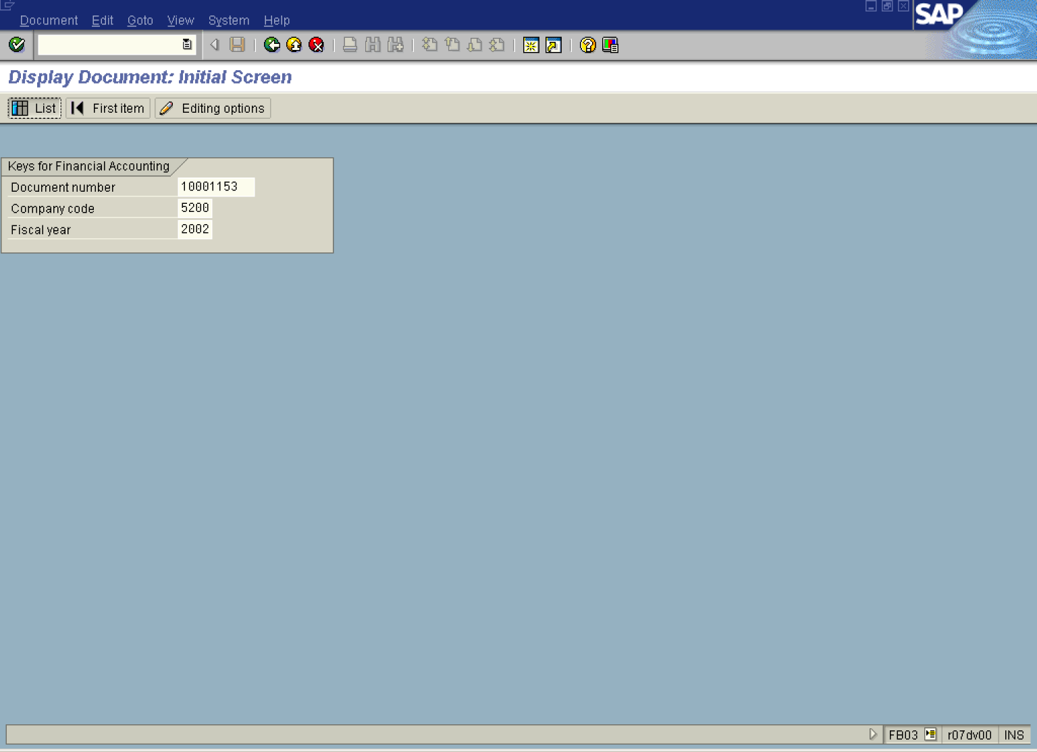

2. If you know the required document number, enter it in the field “Document number”. If you don’t, click List Button to search for documents:

3. The system will display a screen where you can enter your search criteria:

Display Document: Initial Screen

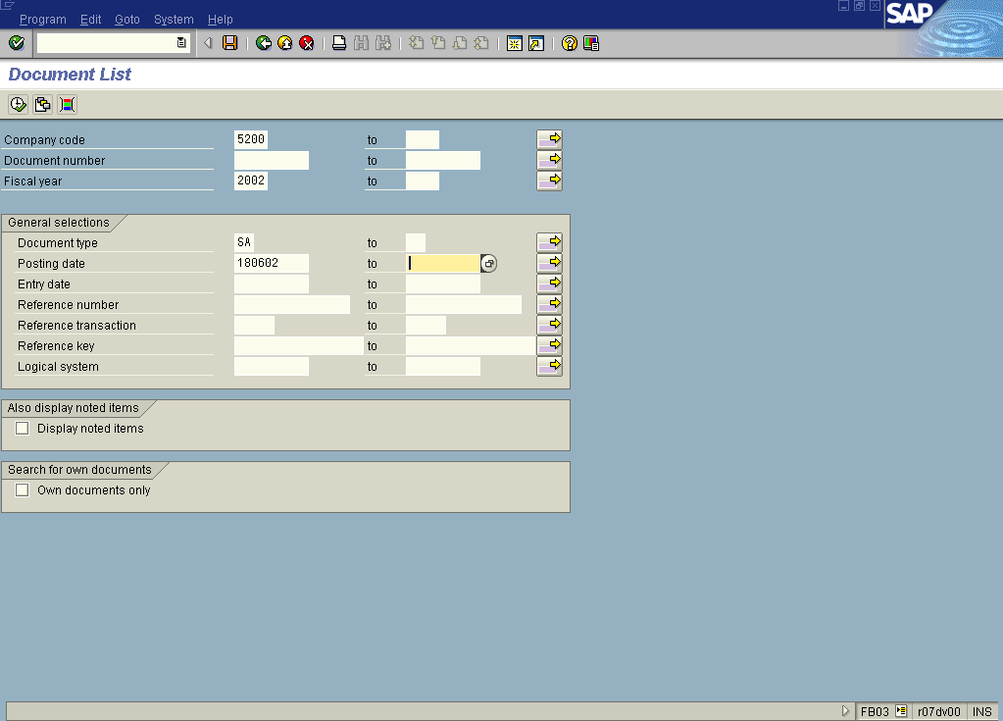

4. Update the following fields:

Field Name | Field Description | Values
Fiscal year | Fiscal year number | Example: 2002
Document type | Code identifying the method that the system uses to process the transaction | Example: SA
Posting date | Date that the business transaction occurred | Example: 180602

5. Click Execute Button to start searching.
6. The system will display a list of documents that fulfill your criteria:
Document List
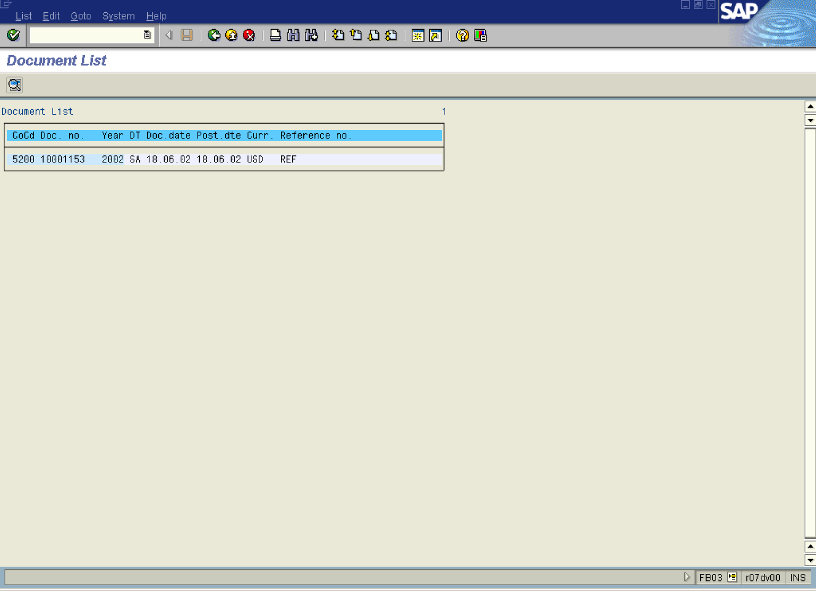

7. To display your document, simply double click on it. The system will display a document overview:

Display Document: Overview

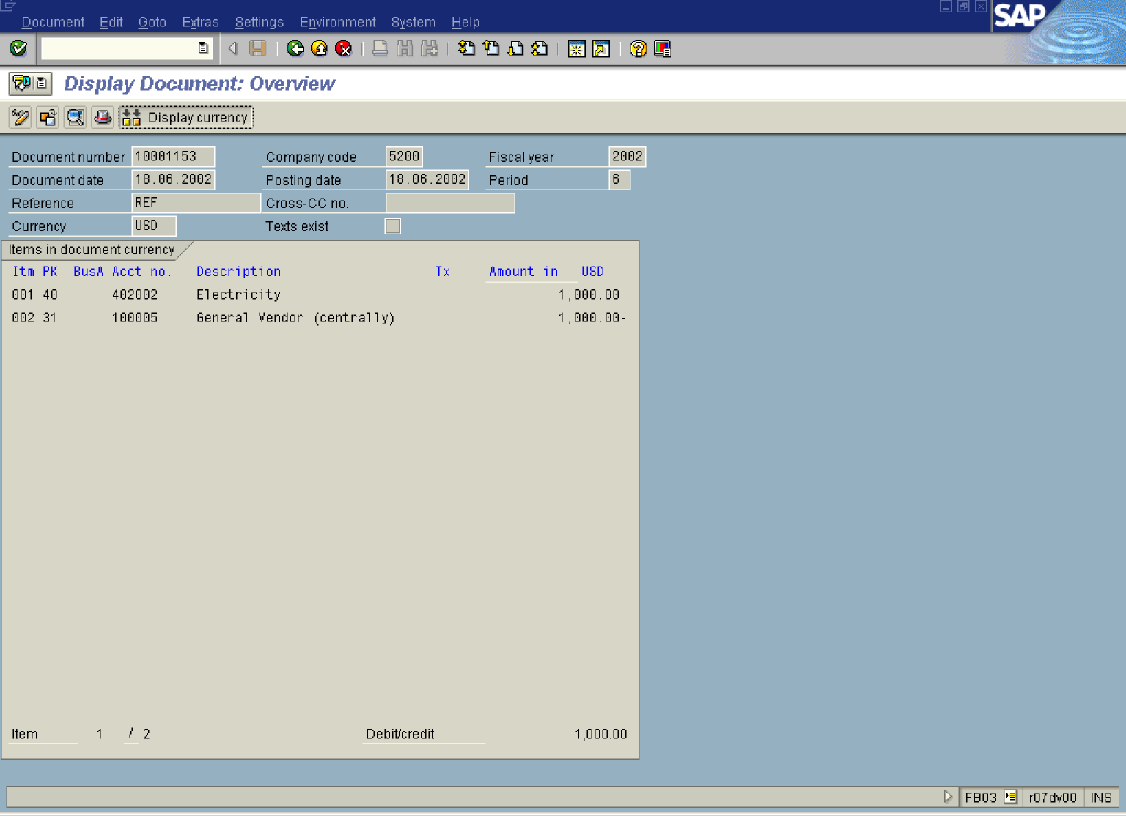

8. You can display your document in different currency. Click Display currency Button .

Display currency for document

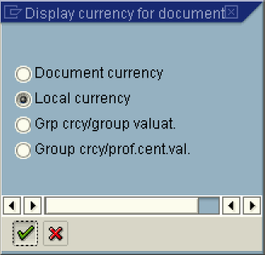

9. Click Local currency .

10. Click Enter

Display Document: Overview

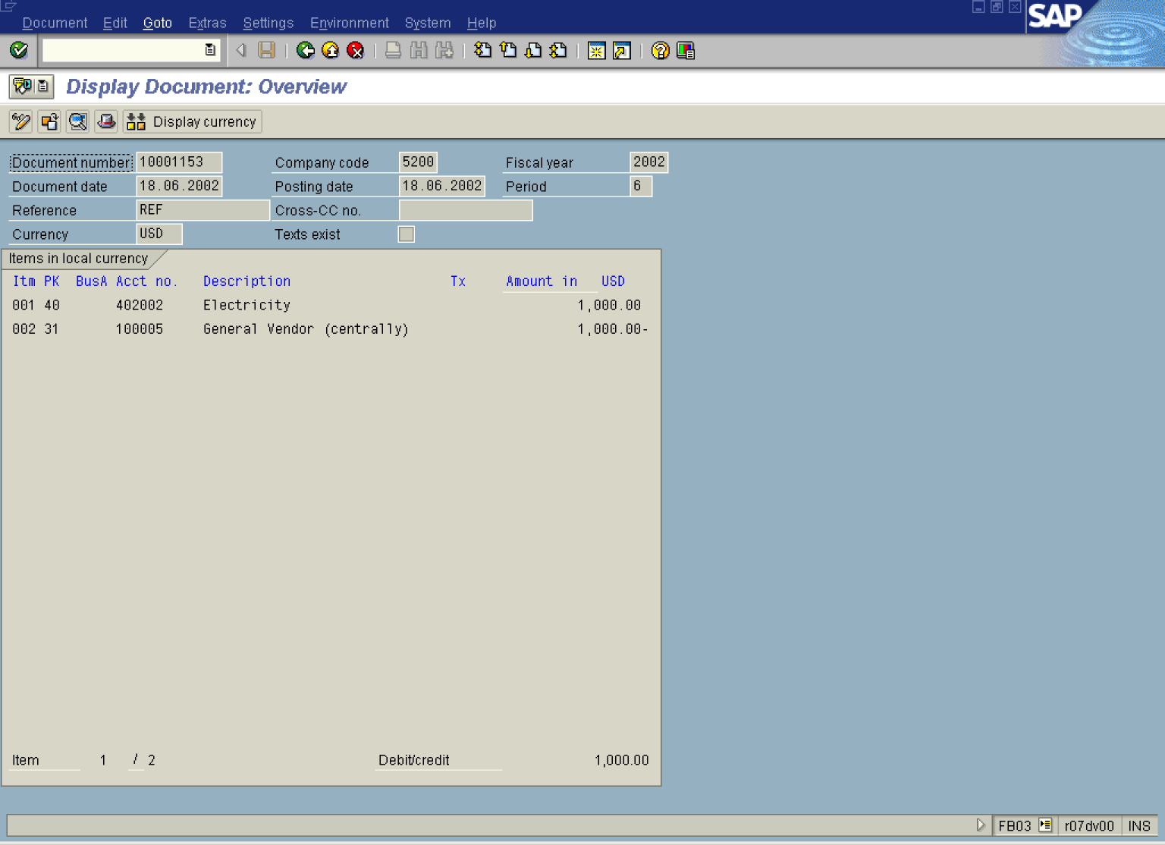

11. You can display also other document details, like e.g. who posted this document. Choose Document Header button. You can see that the user SBTP000197 posted this document on 18th July 2002 – this date is derived from the system clock.
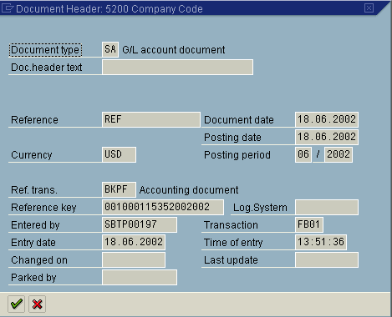

12. If you want to print this document, select from menu path” DocumentDispl ay as list.

Document Overview

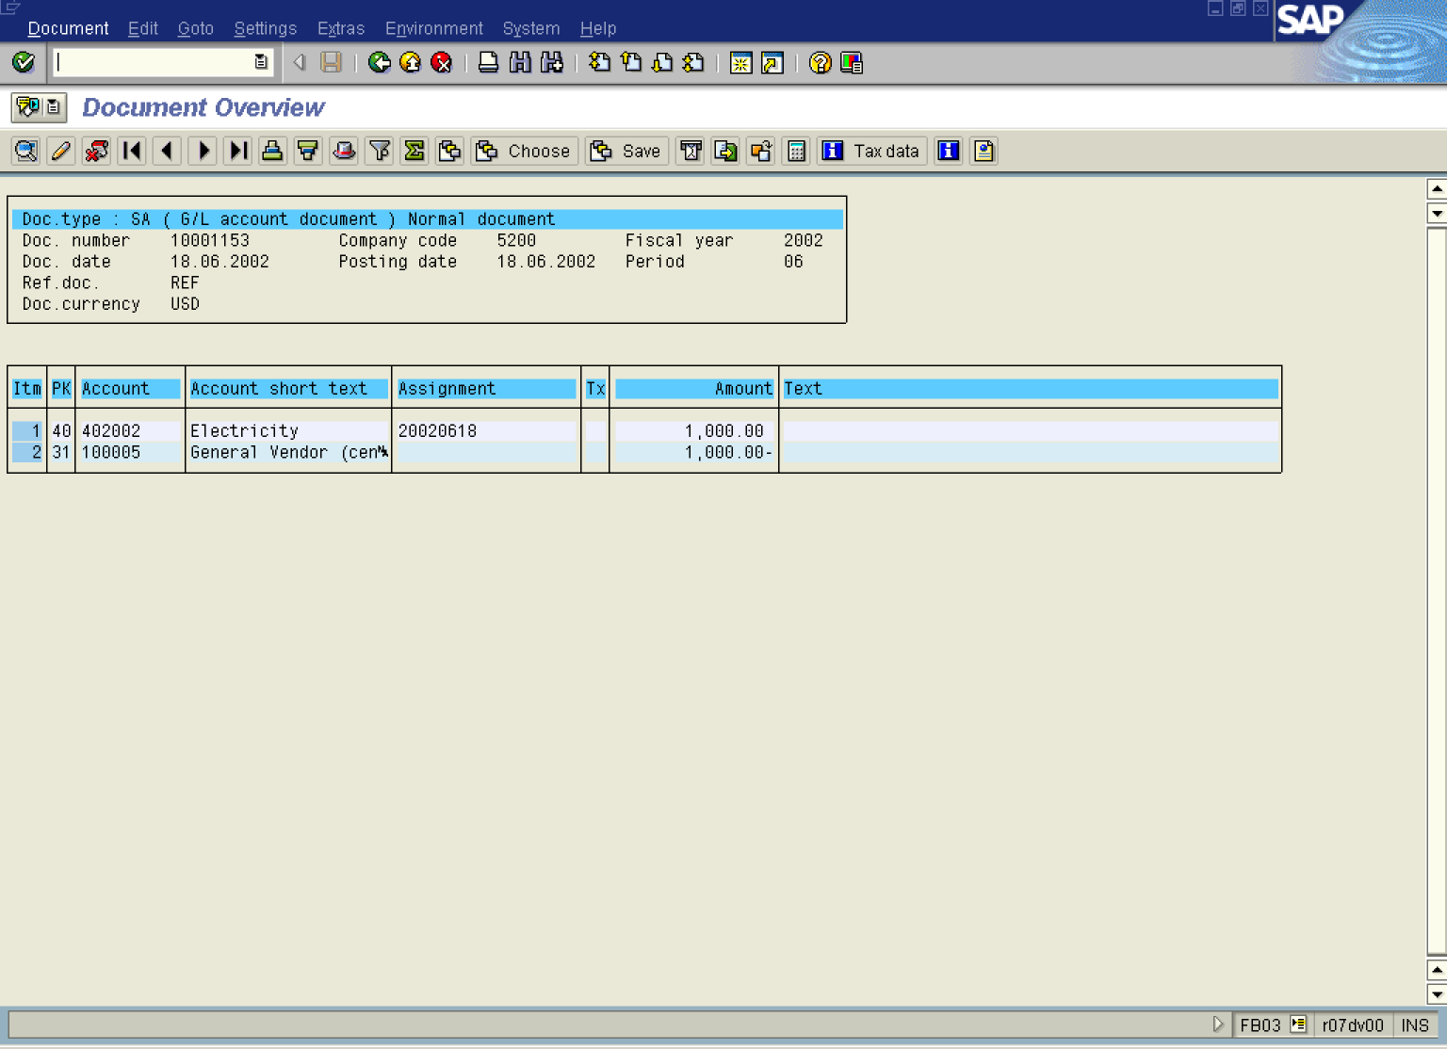

Tip: You can select a different list variant (different fields are displayed). Simply click Choose display variant button.

13. You can print this report (just click on Print icon). But you can also export (download) this report as a MS Office file. Select DocumentExport.

Document Overview

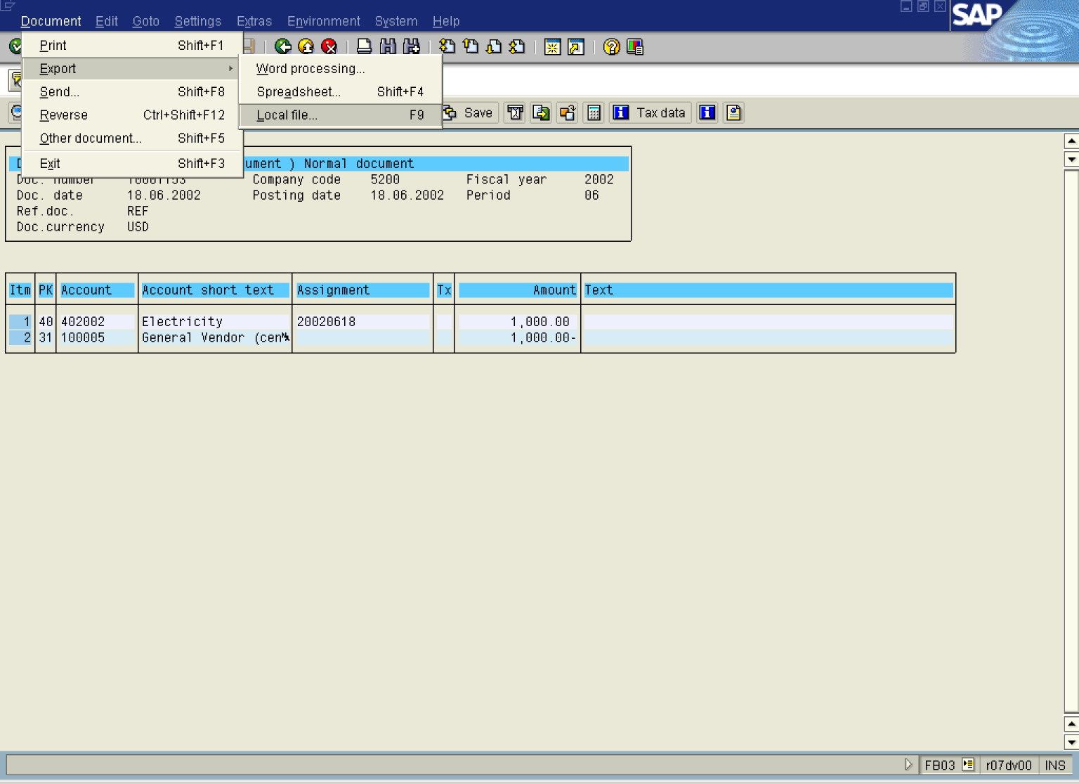
14. Now choose Local File

Save list in file...

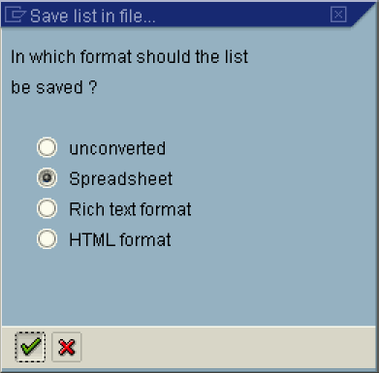

15. Click Spreadsheet .

16. Click Enter Button . Now the system asks you to enter a file name (full path is selected by default, but you can change it).

Transfer DAT to a Local File

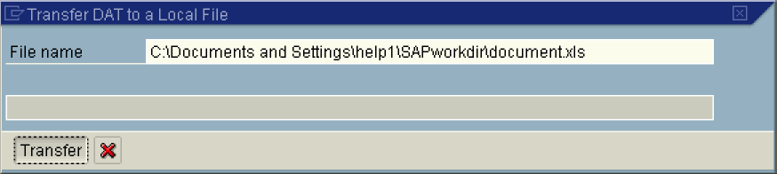

17. Update the following fields:

Field Name | Field Description | Values
File name | Enter your file name here | Example: C:\Documents and Settings\help1\SAPworkdir\document.xls

18. Click Transfer Button . The system saved your report as a MS Excel file.

